

**MAHARAJA SRIRAM CHANDRA BHANJA DEO UNIVERSITY, BARIPADA**

Ability Enhancement Courses as per NEP, 2020

## (Credit-8)

**List of Ability Enhancement Courses**

**(Compulsory Course)**

For Semester-I a student has to choose one MIL from Odia/Hindi/Sanskrit/Urdu/Santali

|  |  |  |  |  |  |
| --- | --- | --- | --- | --- | --- |
| **Semester** | **Subject** | **Credit** | **Full Mark** | **End Sem** | **Mid Sem** |
| I | Odia/ Hindi/ Sanskrit/  Urdu/Santali | 4 | 100 | 60 | 40 |
| II | English | 4 | 100 | 60 | 40 |

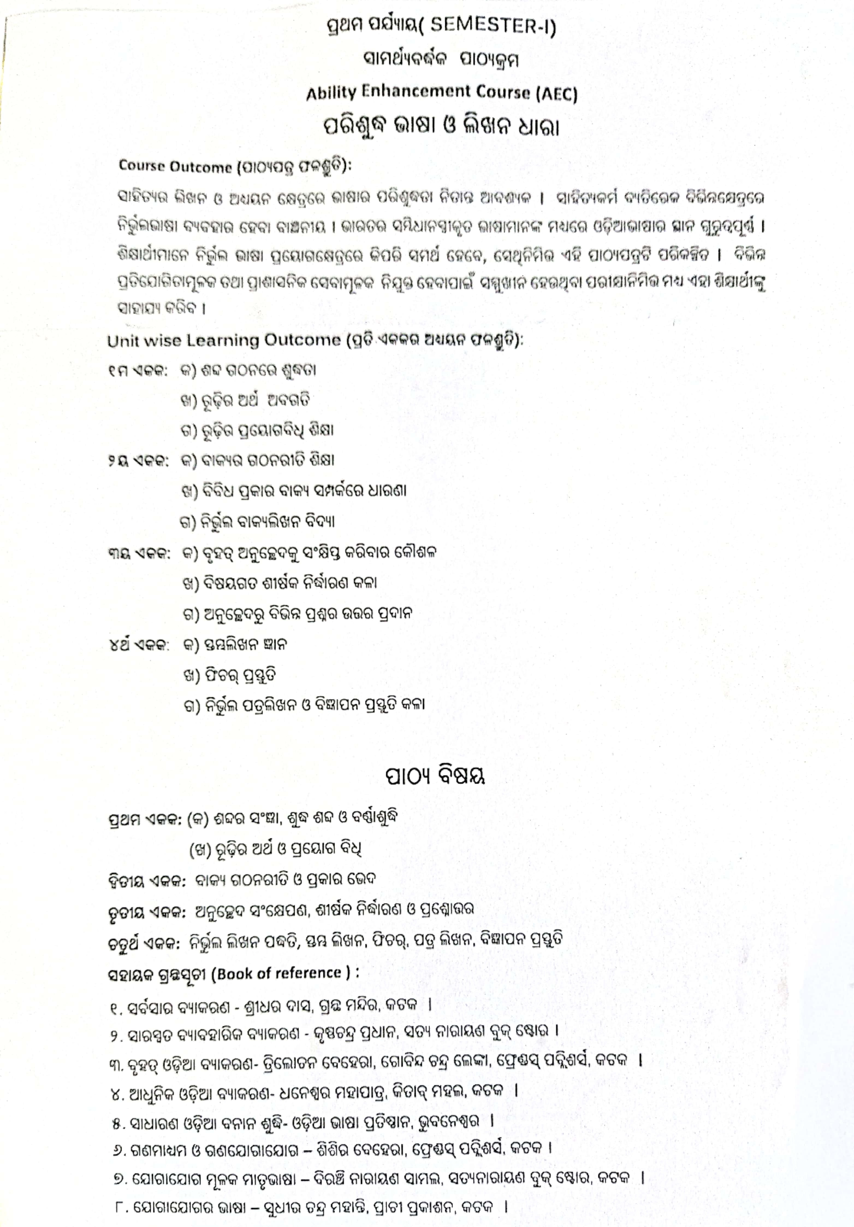



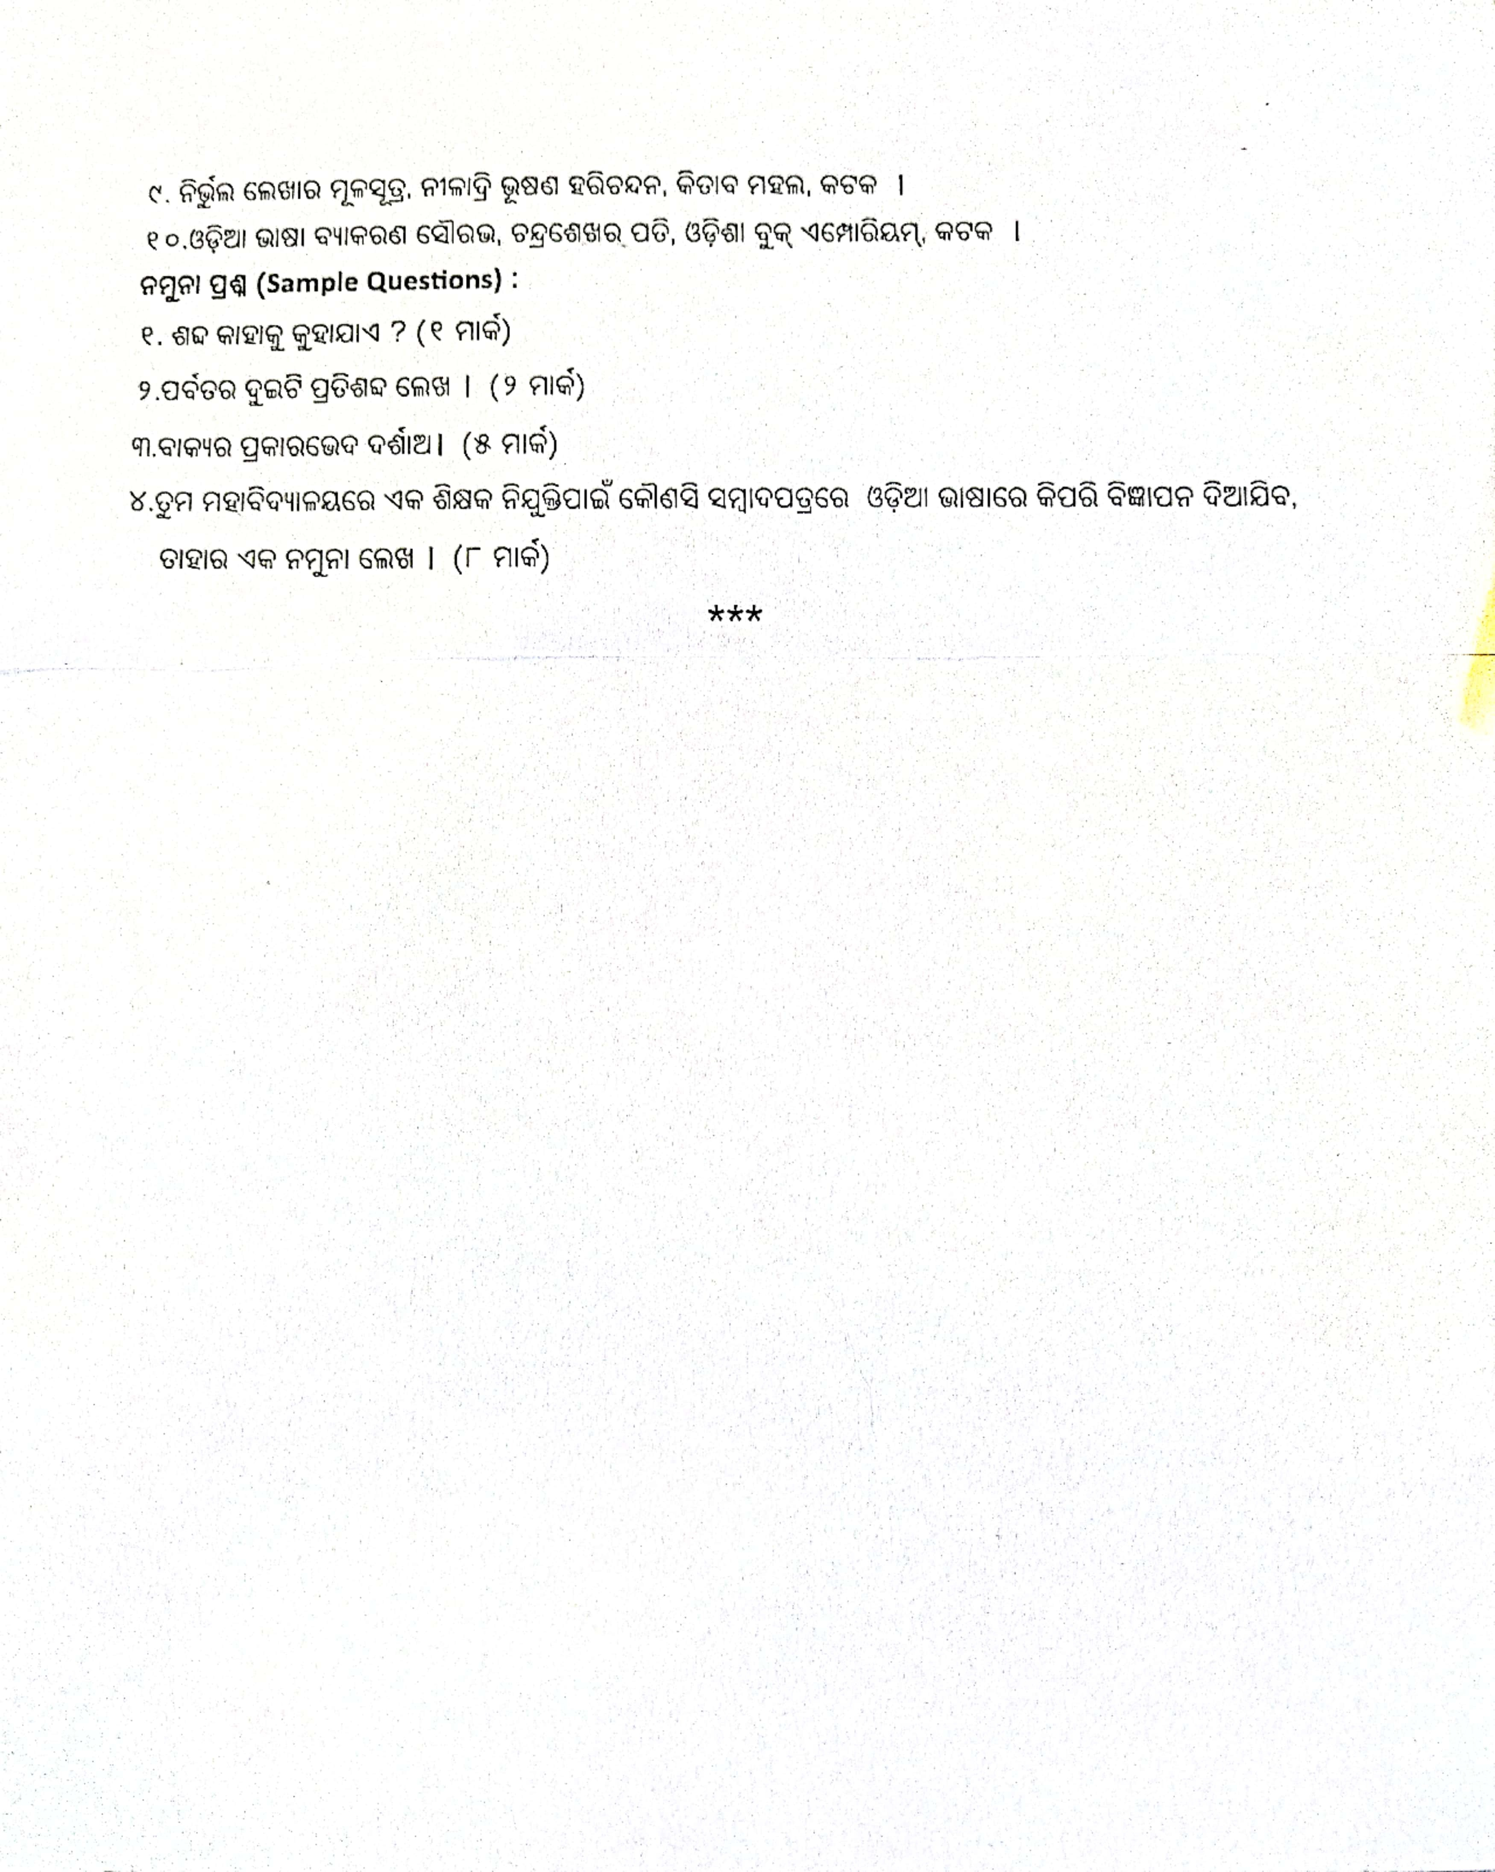



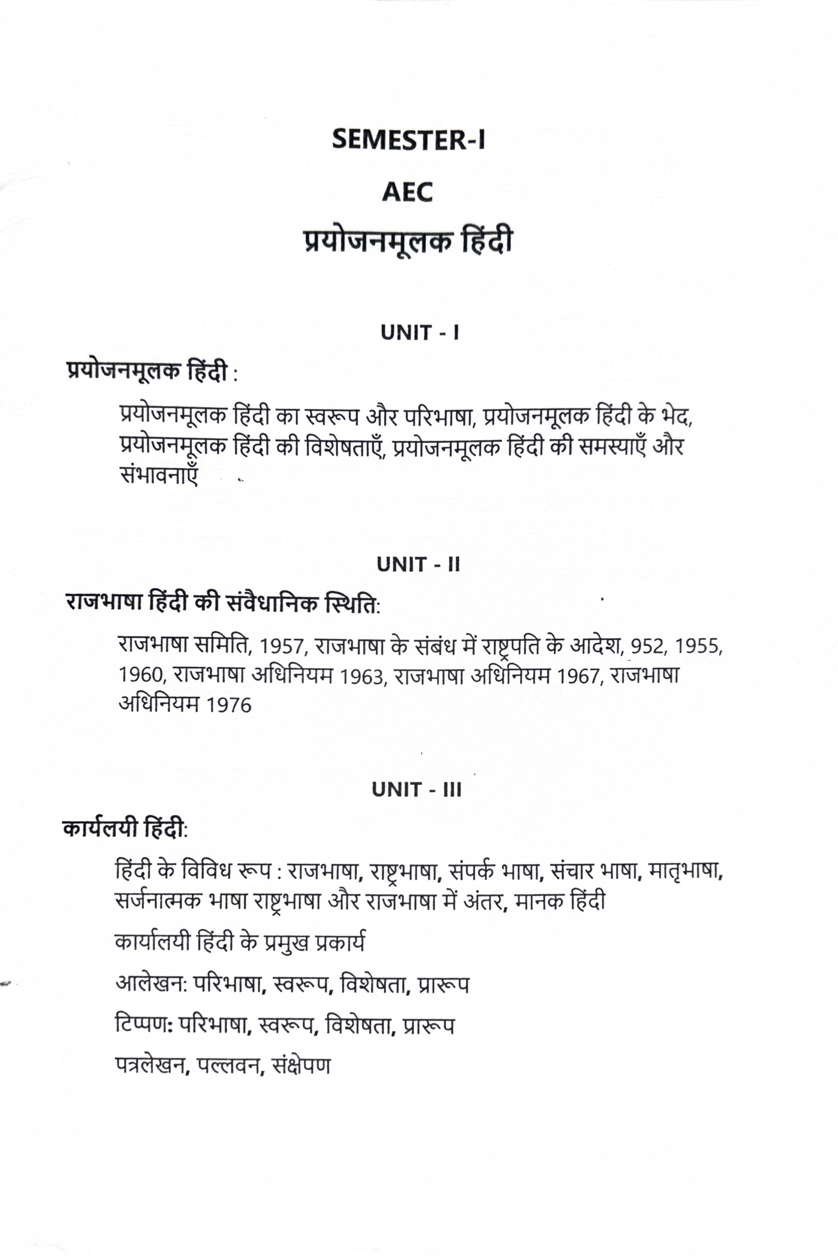

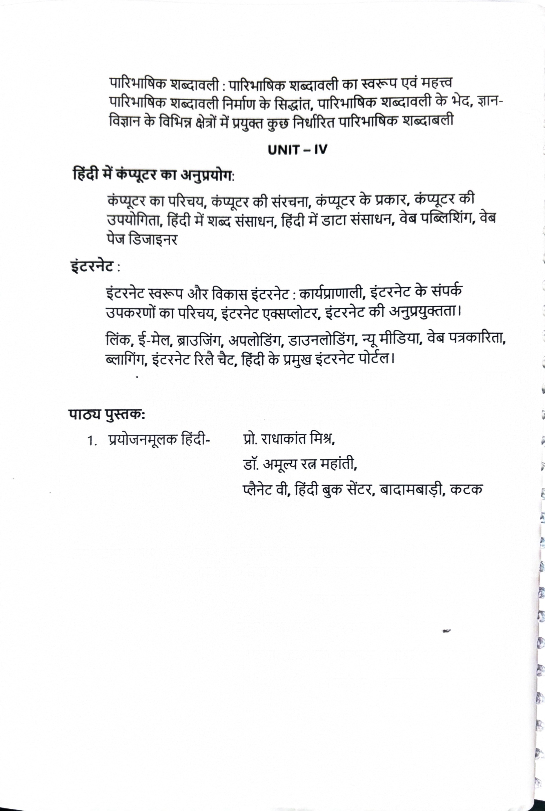

**ABILITY ENHANCEMENT COURSE (AEC)**

### SEMESTER-I

### Functional Sanskrit

Unit-I Sanskrit Alphabets, General Idea about Sanskrit Karaka, Vibhakti, Vacana, Purusa, Pada, Linga, Vacya, Lakara, Upasarga.

Unit-II Useful Sanskrit words, Sentence Formation in Sanskrit, Simple Sanskrit Sentences for conversation, Preparation of News in Sanskrit.

Unit-III Letter writing in Sanskrit, Notice Writing in Sanskrit, Invitation writing in Sanskrit, Description of Festivals in Sanskrit.

Unit-IV Sloka Recitations, Numerical Counting in Sanskrit, Sanskrit Story telling, Self introduction in Sanskrit (Practical).

### Core Readings:

1. Samskrta Vyakarana Darpana,
2. Samskrta Vyakarana manjusa, Kamalesh Bhatia, Chaukhamba Sanskrit Pratisthan, Delhi,2022

### Suggested Readings:

1. Samskrta jnananidhi, Dr.Ram Vilash Choudhuri and Dr. Dhruva Kumari Choudhuri, MLBD, Delhi, Reprint,2016
2. A Higher Sanskrit Grammar, M.R. Kale, MLBD, Delhi,2005

## Ability Enhancement Course (AEC)

## SEMESTER-I

**اردووماصالبورماسالب**

## URDU MOASLAT-O-MORASLAT

**Credit: 4 Full Mark: 100**

Course Outcomes:

* 1. To build up the Primary skill in students to use the langue effectively in public and work domain both.
  2. To give students practice in writing responses and narration of a particular situation.

UNIT-I

Lرشہاور .رن .ان

1۔ .رن .انیکاتیمہواافدی .ت

2۔وماصالیتاردو

**Learning Outcome**: After completion of this unit the learner will be able to explain the relation between society and language and develop understanding about language utility and communicative Urdu.

UNIT-II

.ط،سا ن.قےالےقحواےلاافل .طاوررعیباورافریسعمجاافل .طیکشم باافل

وقادعاوردنبساافلط 1۔اضتمداافل .ط،رتمادفاافل .ط،مہوص

بےکحیحصاامعتسلیکشم

2۔ااضیتف،غطفیاوروتصی.فیرمابک

**Learning Outcome**: After completion of this unit the learner will be able to explain the basic grammar of language and its uses.

UNIT III

باالمن¸ال

رو .ررمہ،احمورےاوررض

1۔رعیبوافریسےساعتسمررو .ررمہ،احمورےاوررضباالمن¸الےکاامعتسلیکشم

2۔ دیسیرو .ررمہ،احمورےاوررضباالمن¸الےکاامعتسلیکشم

**Learning Outcome**: After completion of this unit the learner will be able to explain the uses of native and loan inputs of Urdu language

and develop skill of presentation and expression needed in the academic as well as professional domain.

UNITIV

باگنری

رحترییشم 1۔صیخلتاگنریاورروپر

بووجان .اب

باوروساال .باگنری

2۔ .میہفتاابتقسا

3۔خطوط/دروخاس

**Learning Outcome**: After completion of this unit the learner will be able to uses the language in different situation and develop communicative ability hence creating employability for them.

**نتک**

**وL**

نووقادع(ہصحاولودوم---)عیفشادمحدصیقی

1۔اردو .رن .ا

2۔اردوصف---دمحمااصنراہلل 3۔اردووحن---دمحمااصنراہلل

4۔اردویکاسلینلیکشت---رم .رالیلخادمحیب 5۔اردوصفووحن---ومولیدبعاحل

# Model Questions

01

1۔یسکظفلےکمہینعماافل .طایککہالےتںیہ؟

2۔سا ن.قےےسایکےتھجمسںیہان .کمن¸الےسواحضےیجیک۔ 02

3۔ .رن .انیکاتیمہواافدی .ترپان .کرصتخمونبلکھ یے۔ 05

4۔اےنپوادلوکطخھکلرکاںیہناینپیمیلعترسرگیمےسن .اربخےیجیک۔ 08

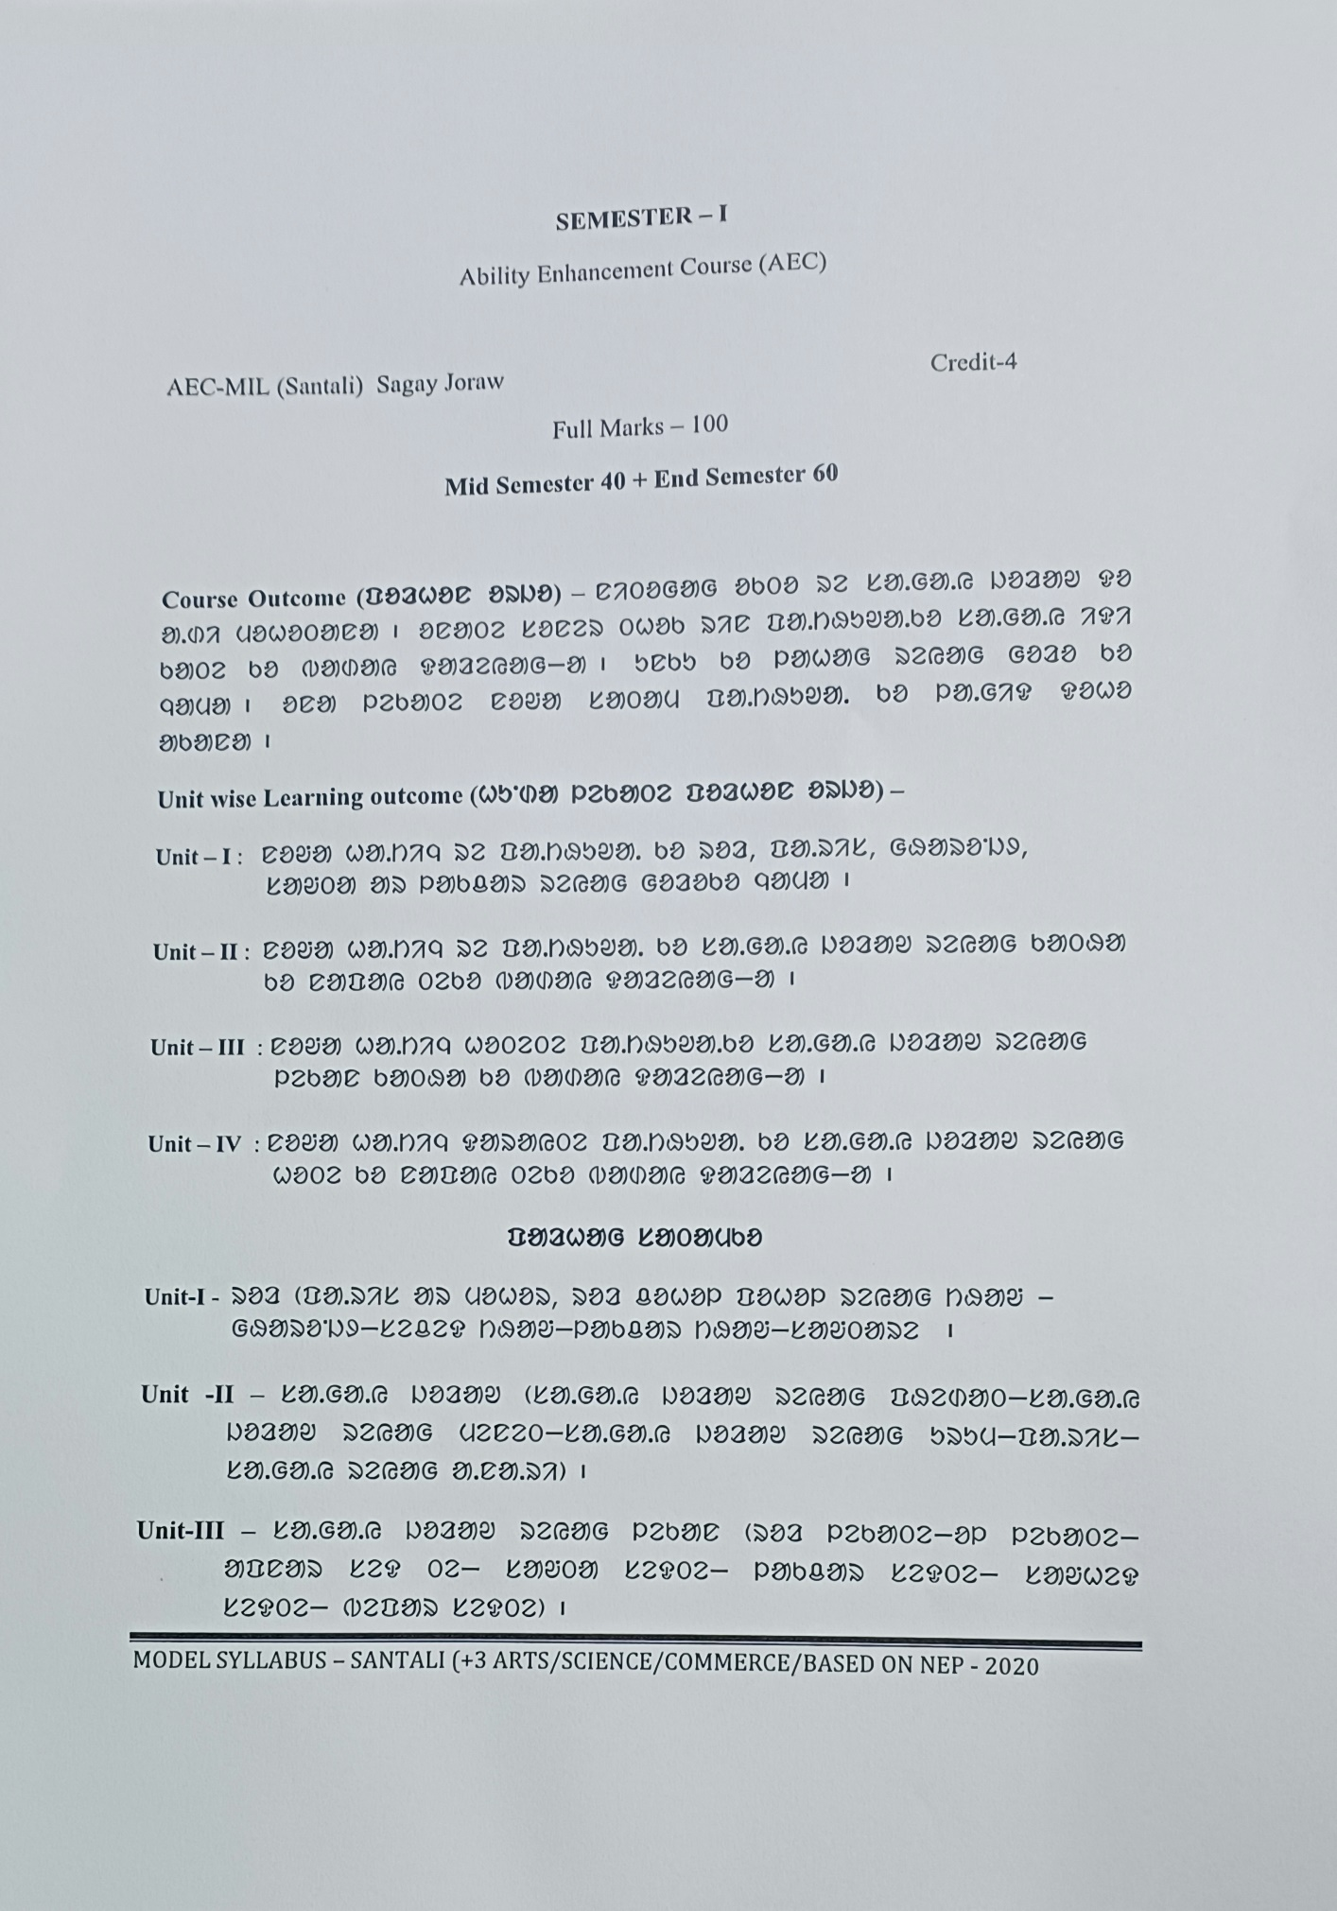

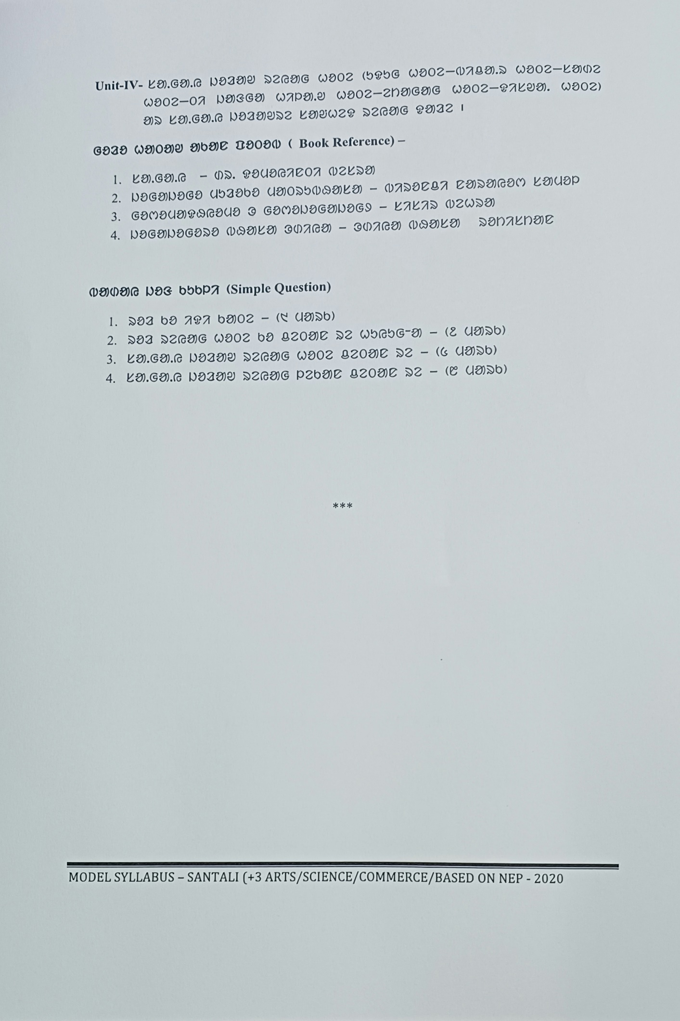

**SEMESTER-II**

**English**

**Introduction:**

This Course aims at providing students familiarity with all components of language learning; listening, speaking, reading, writing, grammar and vocabulary which will eventually help in development of communication skills. This is an activity-based, goal-oriented, functional course, which aims to make the students able and efficient communicators by helping them to be self-reflexive about English. This course has a predefined context of being supportive and complementary to the core courses in various disciplines. Therefore, unlike most other courses in English Communication on offer, it does not seek to build facile fluency that passes off as communicative competence. Rather, it intends to equip the students with the relevant skills of presentation and expression needed in the academic as well as in the professional domains. While reading skills exercises are meant to promote the acquisition of analytical and comprehension skills, writing skills exercises are centred on sentence construction, paragraph development and précis writing. In this course there is ample scope to build the speaking and listening skills of students with an emphasis on interactive learning and articulation.

### Course Objectives

* Develop in students the required knowledge, skills, and judgement around human communication that facilitate their ability to work collaboratively with others.
* Enable the students to understand and practise different techniques of communication. Through this course, they will familiarise themselves with different types of communication. Enhance the employability of students by developing in them the required skills of communication in English, so as to enable them to: 2 i. Speak correctly, intelligibly and fluently as well as to listen and comprehend accurately when spoken to, so as to be able to communicate effectively and with confidence in a variety of social, academic and work-related situations; ii. Read and comprehend accurately the various kinds of written texts which they may be expected to deal with;

iii. Write effectively in a number of different genres (forms) of writing, relevant to social, academic and work-related needs;

* Develop interpersonal skills and the attitudes required for effective functioning in different social and work-related situations.
* Provide cognitive and cultural enrichment through exposure to a variety of humanistic learning experiences. General Pedagogical Principles 1. Instruction will essentially be activity-based. Each session will provide a variety and range of activities, pitched at different levels of linguistic competence. Group activities will be encouraged. The links between theory and practice will constantly be exemplified and highlighted. Theoretical inputs will be provided, as far as possible, in a non-technical manner. 2. Periodical tests may be conducted to assess skills and application of theoretical principles and not recalling information from memory. The skills of Listening and

Speaking may be tested through oral examinations in the classes, depending on time and scope. 3. An inventory of available software, including audio/ audio-visual materials should be made, and the use of such materials be standardised across all colleges. If necessary, software tailored to the requirements of the program should be produced in collaboration with appropriate agencies. 4. Although portions of selected texts will be used to develop the skills, a teacher is free to use material recommended by the experts. 5. The course cannot be effectively implemented unless all instructors are properly oriented. It should be ensured that orientation programs are organised before the curriculum is implemented. Handbooks must be produced and made available to all instructors. 3 6. Workshops for the development of instructional materials by members of college faculties should be organised periodically, as a part of on-going orientation.

### Attention

**The course drives away the myth that communicative competence in a language is honed, built and effectively practiced by learning and mastering the grammar, phonetics of a language or appropriating the accent and structures of the native tongue. Rather it is an adaptation with equal blend of the first language and the context in collaboration with the foreign tongue achieved by suitable use of texts from literature. So the teachers as well as students are advised to use as much literary texts as possible from the texts prescribed and other sources for providing an exposure to the students to be aware of the truth that literature enables skilful communication. The examination questions will be set according to the texts and topics prescribed.**

**Unit-I**

English Language and Communication: Introduction (9 hours)

1. Communication, its importance and factors that determine communication (sender, receiver, channel, code, topic, message, context, feedback, barriers) models of communication, the information gap principle: given and new information; information overload, redundancy and cliches, the importance of audience and purpose ii. Types of communication: horizontal, vertical, interpersonal, lateral and grapevine iii. Verbal and nonverbal communication, body language and its manifestations in different cultures, written and oral communication, bias-free communication, political correctness. iv. Styles of Communication: formal, informal and semi formal Note: The topics listed above should be introduced briefly in the theory classes. The reflections of the students’ understanding may be assessed by the facilitator through exercises. The teacher/facilitator can refer to the books recommended under ‘prescribed readings’ for teaching and exercise purposes. He/she can refer to valid and recognised web-resources and additional titles from renowned publishing houses for the same purpose.

### Texts

* + Communicative English OSHEC Publication. Chapters: Unit-I
  + Literature and Art of Communication by Asima Ranjan Parhi, Madhusmita Pati, Subhra Prakash Das and Shakina Mohol, Cambridge University Press, 2019.
  + The International Encyclopedia of Communication. Malden, MA: Blackwell Publishing. (ebook) 4

### Suggested Readings

* + A Cognitive Approach to Language Learning. Oxford University Press Donsbach, Wolfgang. (2008).
  + ‘Prospect of Electronic Media as Curriculum in Non-Native Contexts’, by Parhi and Dutta in I-Manager’s Journal on English Language Teaching, 4(2)2014. https://files.eric.ed.gov. pdf
  + 21st CenturyCommunication: A Reference Handbook. Thousand Oaks, Calif: SAGE Reference. (e-book)
  + Written and Spoken Communication in English published by Orient Blackswan
  + Indian English through Newspapers, A R Parhi, Concept, New Delhi, 2008.
  + An Introduction to Professional English and Soft Skills by Das et al
  + *Communicative Competence.* T T Panigrahi*,* Notion Press, India, Singapore and Malaysia
  + Soft Skills for Your Career, by Kalyani Samantaray. OUP
  + An Anthology of English Prose 1400–1900 Cambridge University Press 2015.

**Unit-II**

English Language and Communication: Listening and Speaking (9 hours)

I. Types of listening (active and passive), listening to respond (how, when and why), empathic listening and interactive listening ii. Speaking to communicate effectively: fluency, accuracy. intelligibility and clarity iii. Style of speaking in various situations:formal, informal and semi-formal, tentative and cautionary, simple and plain English iv. English pronunciation: vowel and consonant sounds, diphthong, IPA, syllable division and primary stress in words, stress shift, sentence rhythm and weak forms, contrastive stress in sentences, intonation: falling and rising tones, varieties of spoken Englishes: Standard Indian, American and British (R.P.); ‘Neutral English’ , newspapers, ad captions and their contribution to the shaping of Indian English as a standard language

Note: This unit does not go deep into phonetics. The objective is to train students to refer to a Learners’ Dictionary to find out the correct pronunciation of words. Students will be introduced to phonemic transcription using IPA symbols in theory classes and further practice will be provided during exercises/practices.

### Texts

The teacher/facilitator will include simple questions on phonemic transcription and the marking of stress in words and sentences. The teacher/facilitator can refer to the books recommended under both ‘Texts’ and ‘Suggested Readings’ for teaching and exercise purposes. He/she can refer to valid and recognised webresources and additional titles from renowned publishing houses for the same purpose.

* + Communicative English OSHEC publication. Chapter-Unit I
  + The Sound of English by [www.pronunciationstudio.com](http://www.pronunciationstudio.com/)
  + ‘Towards the Anti-Canon: A Brief Focus on Newspaper English in India’, SHSS (Studies in Humanities and Social Sciences, UGC Care), Ed. T.R. Sharma, IIAS (Indian Institute of Advanced Study), Shimla, Vol. XIII, No.1, Summer 2006, pp.143-

155. [http://14.139.58.200,](http://14.139.58.200/) iias.ac.in.journals Asima Ranjan Parhi.

### Suggested Readings

* + The Sounds of English Around the World: An Introduction to Phonetics and Phonology Cambridge University Press
  + “Listening in the Language Classroom”, pp. 58 - 76 DOI: https://doi.org/10.1017/CBO9780511575945.006, Cambridge University Press, Print publication year: 2009
  + An Introduction to Professional English and Soft Skills by Das et al.
  + Teaching the Spoken Language. Cambridge University Press Speaking. Oxford University Press
  + *Communicative Competence.*Notion Press, India, Singapore and Malaysia
  + Exploring Spoken English. Cambridge University Press English Conversation. Oxford University Press
  + **The English Language in India: From Racial-Colonial to Democratic”, *EJBS (The European Journal of Behavioural Sciences)* 3 (1): page:8-16, Dec. 2020. DOI-10.33422/ejbs.v3i1.302**

**Unit-III**

English Language and Communication: Reading and Writing (9 hours)

I. Reading methods and techniques: fluency, accessing meaning, levels of competence, skimming and scanning, global and local reading, silent reading and reading aloud ii. Reading texts to understand literal, metaphorical and suggested meanings (essays, poems and stories), identifying the tone (admiring, accusatory, ironical, sympathetic, ambiguous and neutral etc.) of the writer iii. Writing process: brainstorming, pre-writing, writing and post writing, coherence, cohesion, style, iv. Writing short texts: paragraph writing; writing longer texts: literary writing, academic writing and media writing

**Note**: This unit will focus on the basic principles of reading and writing as forms of communication. The teacher/facilitator may use reading material from literary texts, media writings, non-fiction prose and other written discourses. He/she needs to adopt caution in selecting the reading materials. Reading and writing are related activities. The insights gained through training in reading can be utilised for effective writing. The teacher/facilitator must refer to the chapters and topics from the books recommended under ‘Prescribed Texts’ for teaching and exercise purposes. From which questions will be set for the examination. He/she can refer to valid and recognised web-resources and additional titles from renowned publishing houses for the same purpose.

### Prescribed Pieces/Texts

* + *Communicative English* OSHEC Publication. Chapters:Unit-III
  + From *The Winged Word,* David Greene, Macmillan*.*1974 and *Melodious Songs and Memorable Tales,* 2015:
  + ‘Daffodils’ by William Wordsworth, ‘When we two Parted’ by Lord Byron, ‘The Last Ride Together’ by Robert Browning, “Self Portrait” by A K Ramanujan.
  + From *The Widening Arc*. Kitab Bhavan, 2016, A R Parhi, S Deepika, P Jani :
  + ‘No Learning without Feeling’ by Claire Needell Hollander and ‘The Empty Page’ by Steven Harvey, ‘George V High School’ by Dinanath Pathy

### Suggested Readings

* + The Oxford Essential Guide to Writing Oxford University Press 2000.
  + An Introduction to Professional English and Soft Skills Das et al
  + The Classic Guide to Better Writing: Step-by-Step Techniques and Exercises to Write Simply, Clearly and Correctly Oxford University Press, 1996
  + Ways of Reading: Advanced Reading Skills for Students of Literature Routledge. 2007.
  + ‘Semantic Excess or New Canons? Exploring the Print Media’, Journal of Media and Communication, 2010. Research Gate https:/[/www](http://www.researchgate.net.237/).[researchgate.net.237.](http://www.researchgate.net.237/) A R Parhi
  + An Anthology of English Prose 1400–1900Cambridge University Press 2015

**Unit-IV**

I. English Language and Communication: Grammar and Vocabulary (9hours) i. Grammar for meaning, multiplicity of meaning, grammar in communication ii. Stative and dynamic verbs, modals and auxiliaries, tense and time reference, aspect,voice, modality, negation, interrogation; reported questions and tag questions, complex noun phrases, concord phrasal verbs. iii. Sentence structure: simple, compound and complex, clauses, types of sentences:statement, questions, exclamations,commands iv. Functions of language,usage-oriented vocabulary, neutral vocabulary Note: The teaching of grammar and vocabulary in this unit need to be connected to communication teaching. Teachers/Instructors may select other areas of grammar for review depending on the needs. They will identify the grammatical errors commonly made by their students in speech as well as writing.

The remediation of these errors may require some explanations of grammar. Instructors should use many grammar and vocabulary related exercises and through them will provide all the grammatical information needed to explain the errors that are identified. The teacher/facilitator can refer to the books recommended under ‘suggested readings’ for teaching and exercise purposes. He/she can refer to valid and recognised web-resources and additional titles from renowned publishing houses for the same purpose.

### Texts

* + Communicative English OSHEC publication. Chapters: Unit-III Communicative Grammar of English by Geoffrey Leech. Routledge publications, 2002
  + Oxford Practical English Usage (International Edition 2016) by Michael Swan

### Suggested Readings

* + The Widening Arc, Kitab Bhavan, Asima R Parhi, S Deepika, P Jani, 2016.
  + Writing Skills Remapping: An Anthology for Degree Classes Orient Blackswan
  + An Anthology of English Prose 1400–1900 Cambridge University Press 2015

### Scheme of Evaluation

* + Midterm test: 20 marks

5x1=5 (short answer, short notes, comprehension questions)

5x1=5 (Analytical, perspective-based and critical-analysis questions)

5x2=10 (activity/practice/reports/case studies/response papers/assignments etc.)

**The teacher will have the flexibility of conducting internal examinations or assess the students’ learning outcomes through activities, short projects, case studies etc. from all 20 marks/ in parts**

### Final Examination: 80 marks

**Unit1: 1 long answer question+ 1 short note/analysis (15+05) =20 marks**

### Unit 2: 1 long answer question+ 1 short note/analysis (15+05) =20 marks

**Unit 3: 1 long answer question+ 1 short note/analysis (15+05) =20 marks**

### Unit 4: 1 long answer question+ 1 short note/analysis (15+05) =20 marks